**Introduction Page**

The following graphic is available via Microsoft Forms. The title *‘Help develop a local sports plan in your County’* and narrative *“This children and young person’s survey was developed by [insert] County Council in collaboration with the Local Sports Partnership who are developing local sports plans in their areas. All responses are anonymous. In case of any issues using this survey please contact [insert]”*. Can be used across other platforms.

**Page 1: About You**

|  |  |  |  |  |
| --- | --- | --- | --- | --- |
| Question | Response Type | Response Options | Logic | Notes |
| 1. What class/year are you in? | Drop Down | * 5th Class * 6th Class * 1st Year * 2nd Year * 3rd Year * Transition Year * 5th Year * 6th Year * University or College | None | n/a |
| 2. Which electoral area do you reside in? | Drop Down | Insert electoral areas relevant to local authority | None | n/a |
| 3. Which of these best describes your gender identity? | Multiple choice | * Male * Female * Prefer not to say * A gender not listed here * Other | None | n/a |

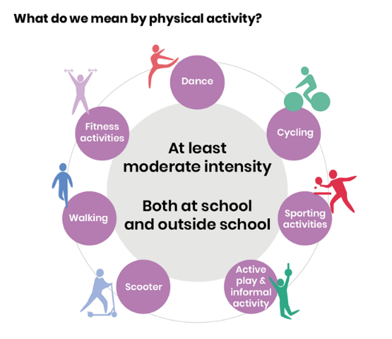**Page 2: How Active are you?**

* Image opposite can be used to describe what is meant by physical activity

|  |  |  |  |  |
| --- | --- | --- | --- | --- |
| Question | Response Type | Response Options | Logic | Notes |
| 1.Over the past 7 days, on how many days were you physically active for a total of at least 1 hour per day? | Ranking/ scale | * 1 * 2 * 3 * 4 * 5 * 6 * 7 | None | n/a |
| 2. How important is sport/physical activity to you? (5 hearts = very important, 1 heart = not so important) | Ranking/ scale | * 1 heart * 2 hearts * 3 hearts * 4 hearts * 5 hearts | None | n/a |
| 3. How easy is it to take part in sport or to be active where you live? (5 ticks = very easy, 1 tick = not easy at all) | Ranking/ scale | * 1 tick * 2 ticks * 3 ticks * 4 ticks * 5 ticks | None | n/a |
| 4. Are you a member of a sports club or physical activity group? | Check boxes | * Yes * No | None | n/a |
| 5. If yes, what is the name of the club or group? | Space for respondent to type answer | Open ended text box | None | n/a |
| How do you find out about sport and physical activity? | 5 Check Boxes accompanied by visual prompts  1 open ended text box | 1. Friends      1. School      1. Parents/Guardian or other family 2. Online      1. Posters/Flyers     6. other (fill in response) | None | Copy and paste images |
| What stops you from being more active? (Choose your top 2 reasons) | 10 check boxes accompanied with visual prompts  1 open text box for respondent to submit answer | 1. Don't have enough time      1. Not sure what activities are available in my area 2. Don't feel confident, or often feel nervous about participating      1. Not enough facilities in my area      1. It's difficult for me to get to sporting activities 2. There are no sports or activities that I am interested in where I live      1. haven't enjoyed sport and physical activity when I've tried it 2. I've never been asked to take part      1. I'm not good enough at sport      1. My parents/an adult cannot or will not take me 2. Other: | Please select 2 options: | Copy and paste images |

**Page 3: Your Favourite Sports and Activities**

|  |  |  |  |  |
| --- | --- | --- | --- | --- |
| Question | Response Type | Response Options | Logic | Notes |
| Which of the following sports and activities do you take part in most often or are you most interested in? Choose up to 5 | Check boxes  1 open text box for respondent to type answer | American Football  Archery  Athletics  Badminton  Basketball  Bowling  Boxing  Camogie  Canoeing  Cricket  Cycling  Dance  Fencing  Fitness classes  Football (Soccer)  Gaelic Games (Gaelic football, hurling, handball)  Golf  Gymnastics  Handball  Hockey  Horse Sport  Ice Skating  Jogging  Judo  Kayaking  Martial Arts  Mountaineering  Pilates  Racquetball  Rowing  Rugby  Running  Sailing  Squash  Surfing  Swimming  Tennis  Trampolining  Volleyball  Walking  Waterpolo  Weightlifting  Wrestling  Yoga  None of the above  Tennis  Other: open ended | none | n/a |

**Page 4: The Future**

|  |  |  |  |  |
| --- | --- | --- | --- | --- |
| Question | Response Type | Response Options | Logic | Notes |
| 1. What would help get you more active in sport and physical activity (choose the top 2) | Check boxes accompanied by visual prompts | 1. Make it fun 2. Help me find out about sport and physical activity in my area 3. Make sure young people feel welcome      1. Make it easier to travel to sport and physical activity 2. Provide different types of sports and activities 3. Improve facilities in my area      1. If my parents/guardians were more involved | Please select two options | Copy and paste images |
| 2. In your own words, what things could your County Council or other groups do to encourage you to participate more in sport and physical activity? | Open text box for respondent to type answer | 1. Open ended empty textbox (enter your answer) | none |  |

**Page 5: Play (Optional)**

|  |  |  |  |  |
| --- | --- | --- | --- | --- |
| Question | Response Type | Response Options | Logic | Notes |
| What are your favourite ways to play? (Choose up to 3) | Check boxes with visual prompts | 1. Be Active - run, jump, swing, ball games, skip, chase    2. Hang Out – meet friends, chat, laugh, shout, sit around    3. Use Wheels – cycle, scooter, skate, skateboard    4. Get Wet or Grubby – paddling, mud, digging, mixing, buckets    5. Be adventurous – climb, be daring, hang upside down, jump from high up, swing high, walk on logs    6. Make Things – create, draw, paint, build things, make dens    7. Be Quiet - imagine, dream, invent, hide, chill    8.Getting Techno - Gaming, watch tv, YouTube etc, play on phone    9.Other - Reading, boardgames, cards | (Choose up to 3) | Copy and paste images |
| Where are your favourite places to play? Choose up to 3 | Check boxes with visual prompts | 1. Garden or friends garden    2. In the street    3. Local park with trees, bushes, fields    4. Playgrounds    5. Play areas with sand, water, trees    6. Sports pitches or multi use games areas    7. Cycle track or skate park    8. Community centre or youth club    9. Woods or forests    10. Close to rivers, lakes or canal    11. School playground |  |  |
| What stops you playing more? | Check boxes  1 open ended text box for respondent to type answer | * Bad weather * I don't have anywhere to go to play * My parents or guardian don't allow me to play as much as I'd like * I don't have enough time * Too busy with school work or homework * I'm worried about how safe I would be * Other: |  |  |
| In your own words, what things could your County Council or other groups do to encourage you to participate more in play activities? | Open text box for respondent to type answer  Online voice notes recording link | 1.Open ended empty text box (enter your answer) | none |  |

**Conclusion**

These templates were created by Sport Ireland with the support of 8 Local Authorities (Carlow, Cavan, Clare, Dun Laoghaoire Rathdown, Dublin City, Fingal, South Dublin) and S3 Solutions in 2024.

Contact [participation@sportireland.ie](mailto:participation@sportireland.ie) with any queries.

